Imorovements :

* When application opens in samall devices then left navigation slider should be closed by default. Currently it is opened.
* On Android we have to improve the UI design for the left navigation slider i.e remove extra space for Android platform.
* On Android when you clicks on default device back button it will cause application close. It should navigate screens based on ZC Mobile behaviour.
* When navigation slider is closed then it is displaying some blue color gap on left and top position. And it is also displaying blank navigation bar on top. i.e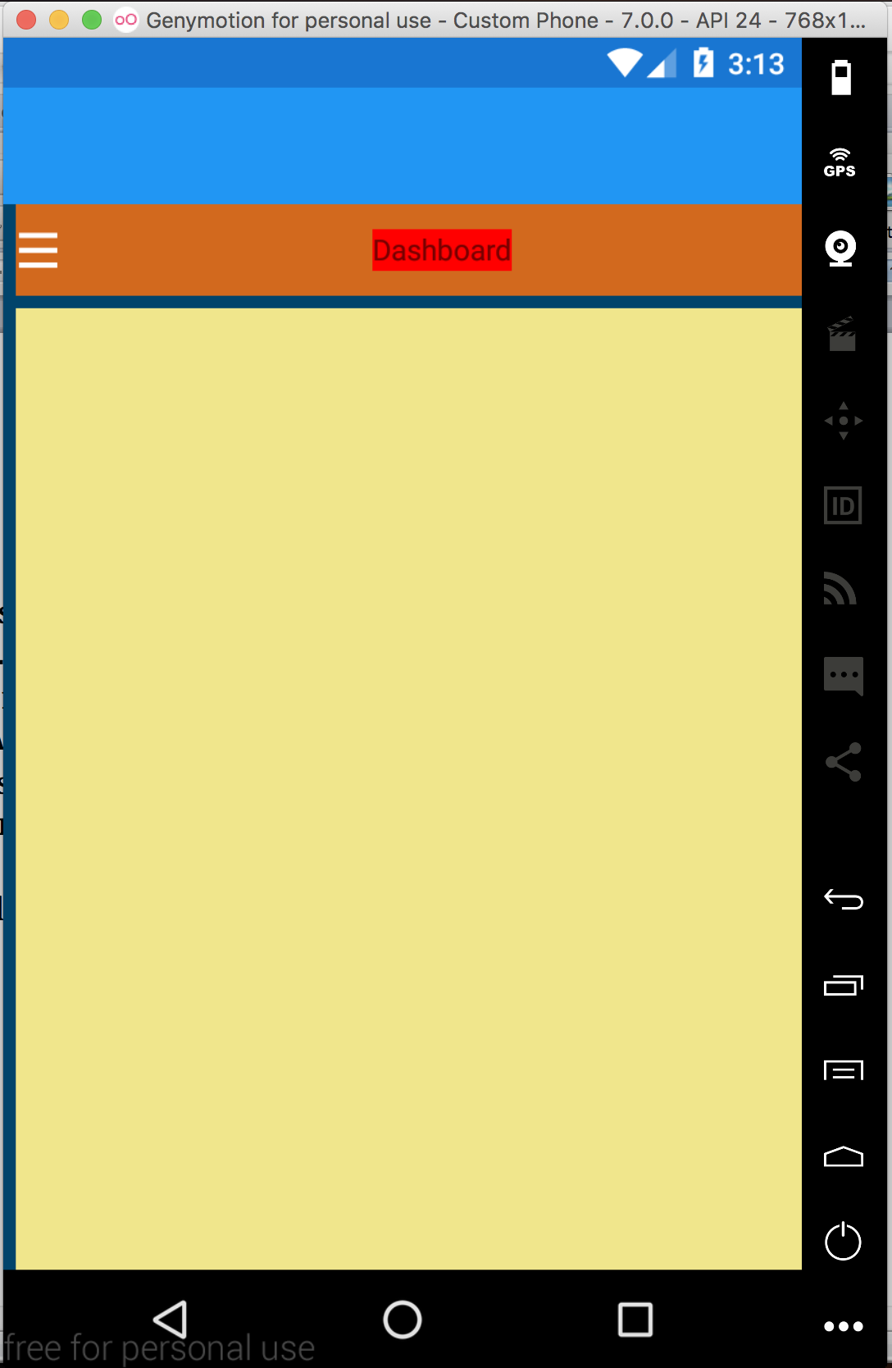
* Currently left navigation section are not toggly open close on click on same section. It remains open so we have to made change regarding that as well.
* Page contents gets shrinked when left slider is opend.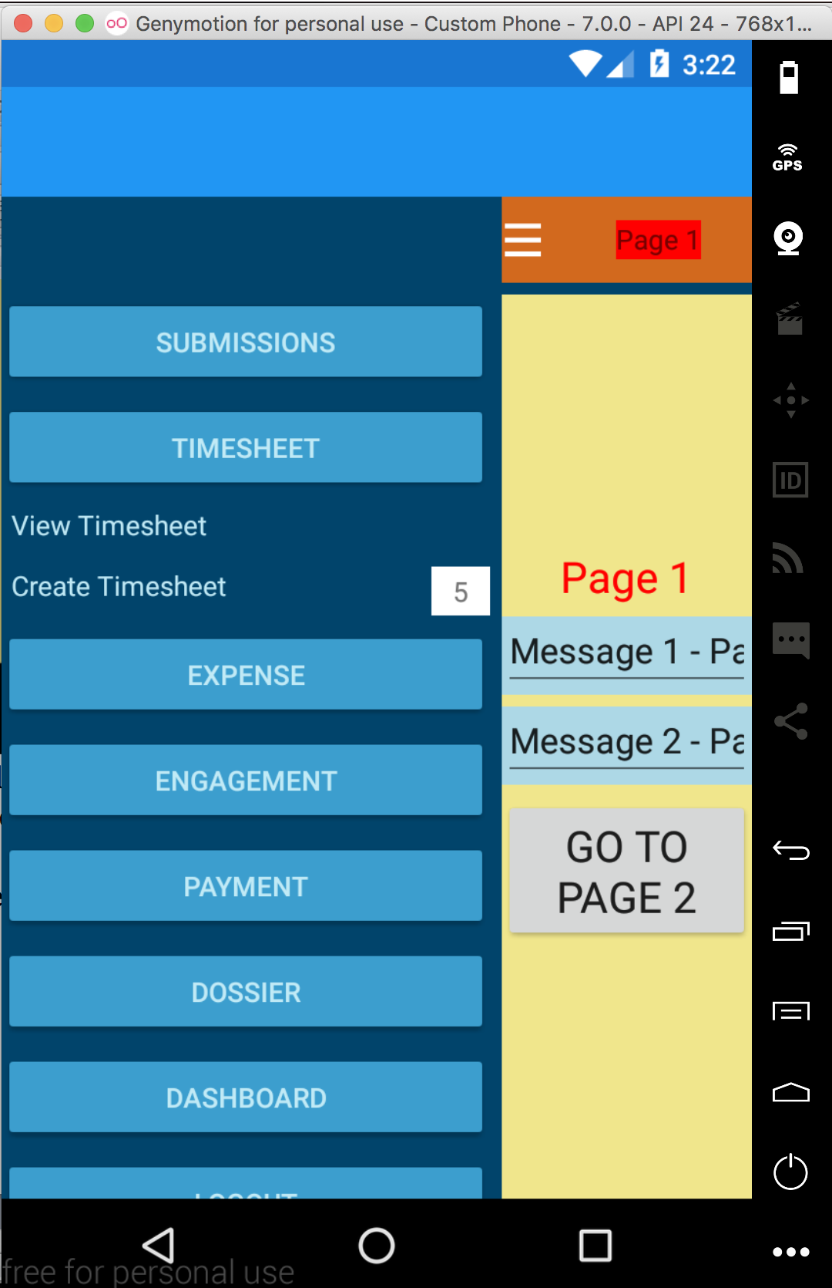
* On Android platfrom activity indicator is behaving uneven.
* Missing ZC Icon on the top left side of slider to close the left slider.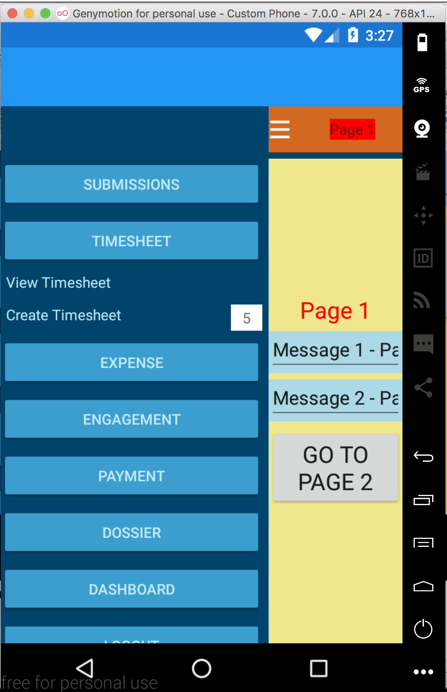
* Right now on Andorid platfrom it is displaying back button. Expected behaviour is only show back button for iOS platform.
* Right now it is not showing …. Section on the Android Tablet in both L and P mode of the application.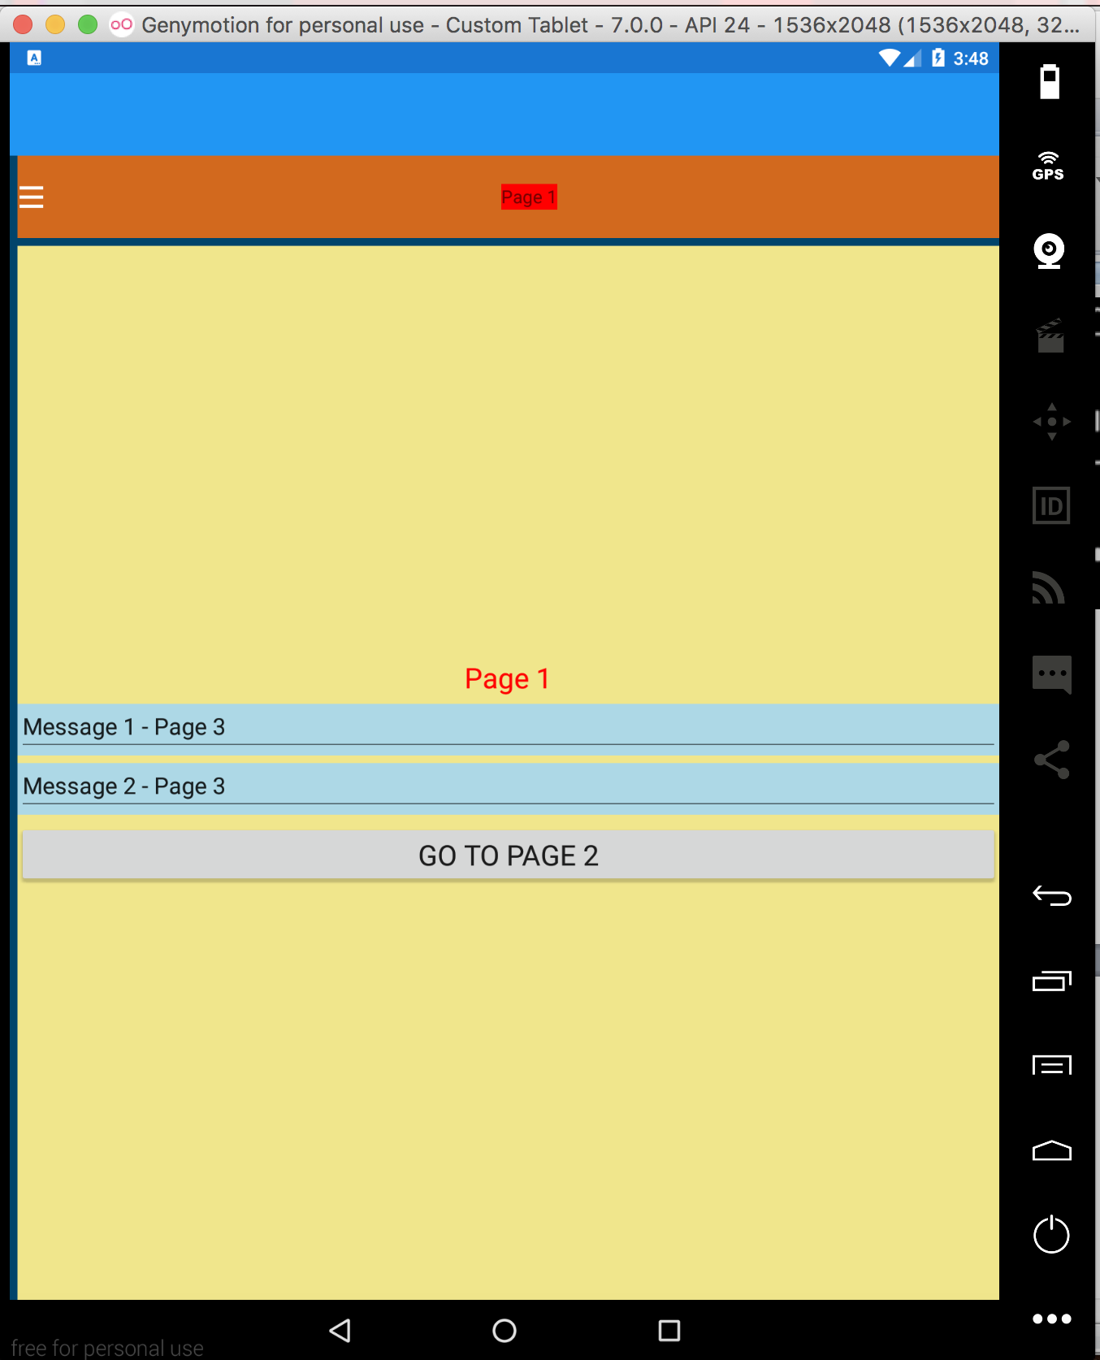
* Right now it is not handling application UI when Tablet device is rotating from land scape to Portrait and visa versa.